**TASK 1:**

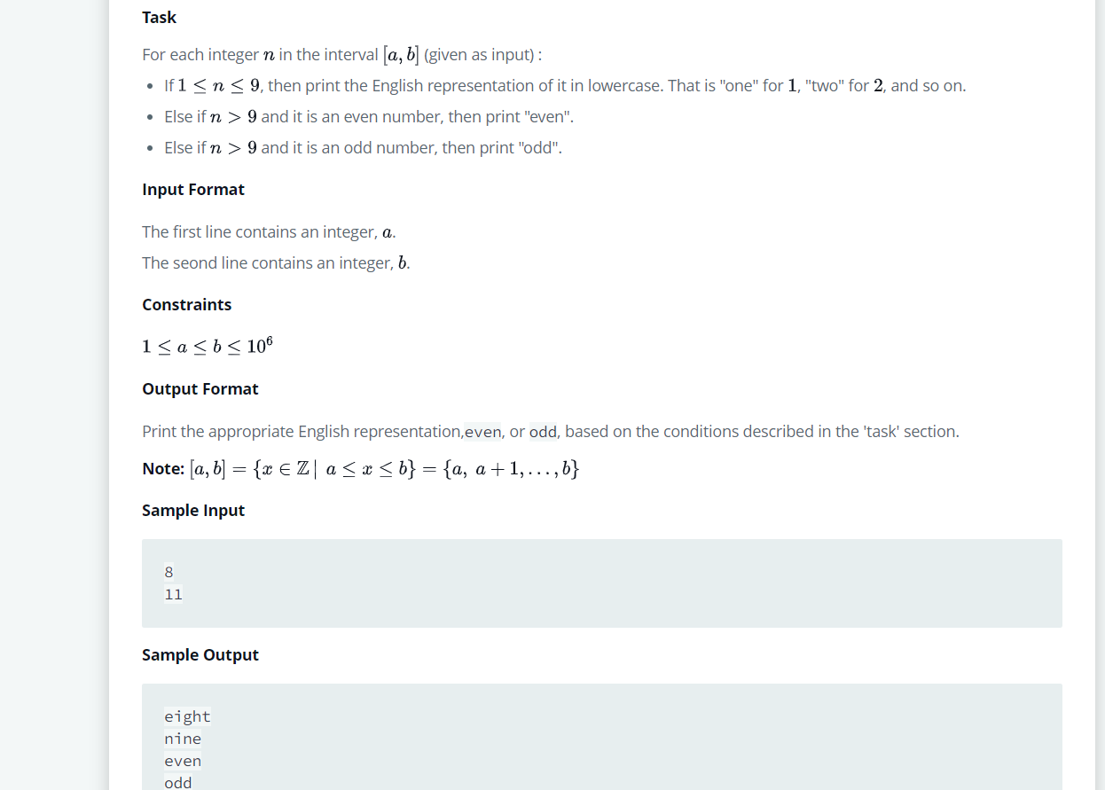

**CODE:**

#include <stdio.h>

int main() {

int a, b;

scanf("%d \n%d", &a, &b);

for(int i=a; i<=b; i++) {

switch (i) {

case 1:

printf("one\n");

break;

case 2:

printf("two\n");

break;

case 3:

printf("three\n");

break;

case 4:

printf("four\n");

break;

case 5:

printf("five\n");

break;

case 6:

printf("six\n");

break;

case 7:

printf("seven\n");

break;

case 8:

printf("eight\n");

break;

case 9:

printf("nine\n");

break;

default:

if((i%2) == 0)

printf("even\n");

else printf("odd\n");

break;

}

}

return 0;

}

**OUTPUT:**

